Aim: To understand the Kubernetes Cluster Architecture, install and Spin Up a Kubernetes Cluster on Linux Machines/Cloud Platforms.

Steps:

1. We will create 3 EC2 instances. One will be the master node and the other 2 will be slave/worker nodes.

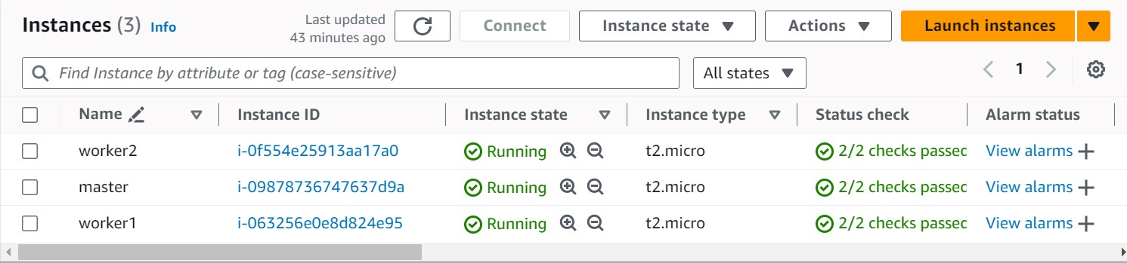

1. After the instances have been created, we will connect them one by one.

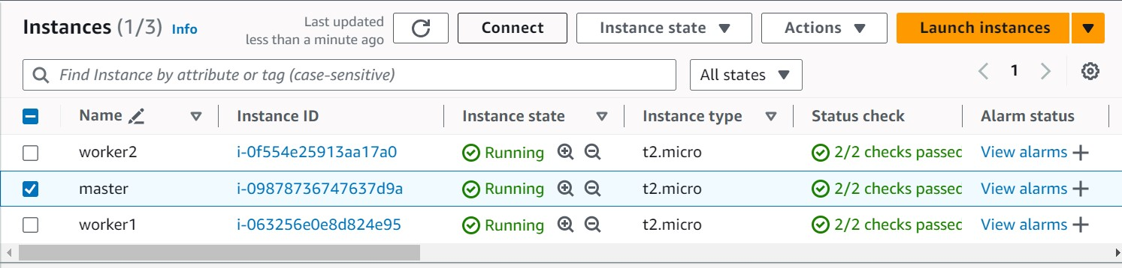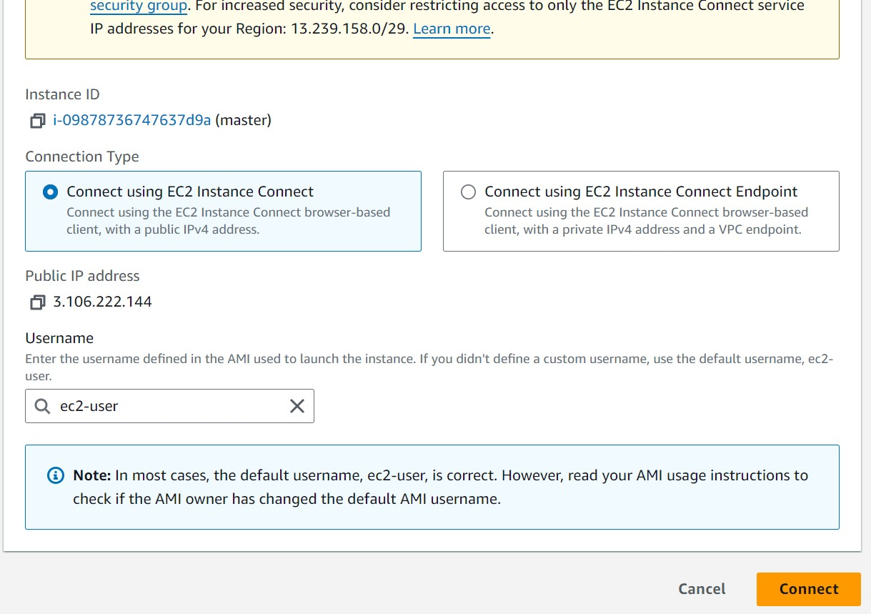

1. Docker installation:

This step has to be performed on all the 3 instances. The following command has to be run:

yum install docker -y

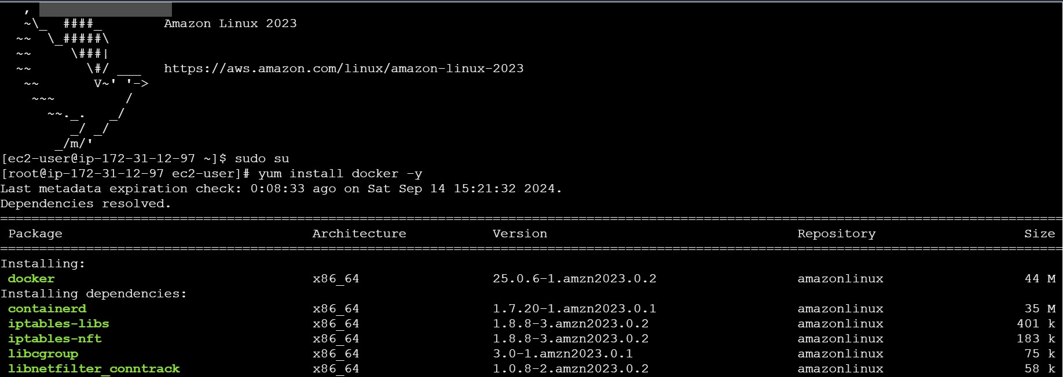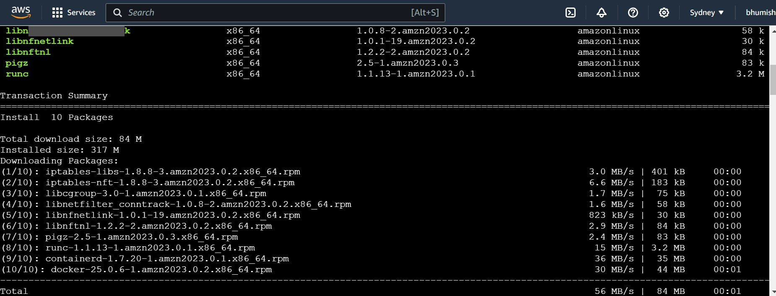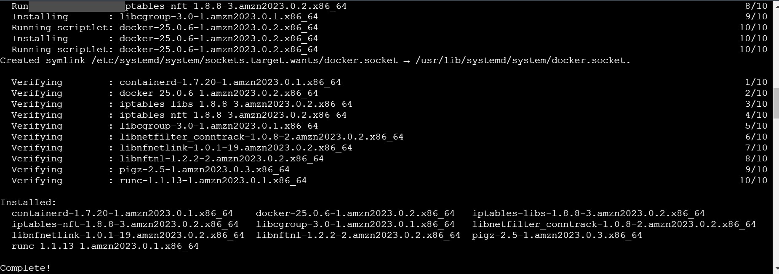

1. After successfully docker has been installed it has to be started on all machines by using the command “systemctl start docker”



1. Kubernetes installation:

Search kubeadm installation on your browser and scroll down and select red hat-based distributions.

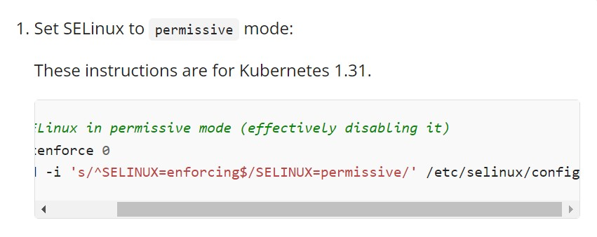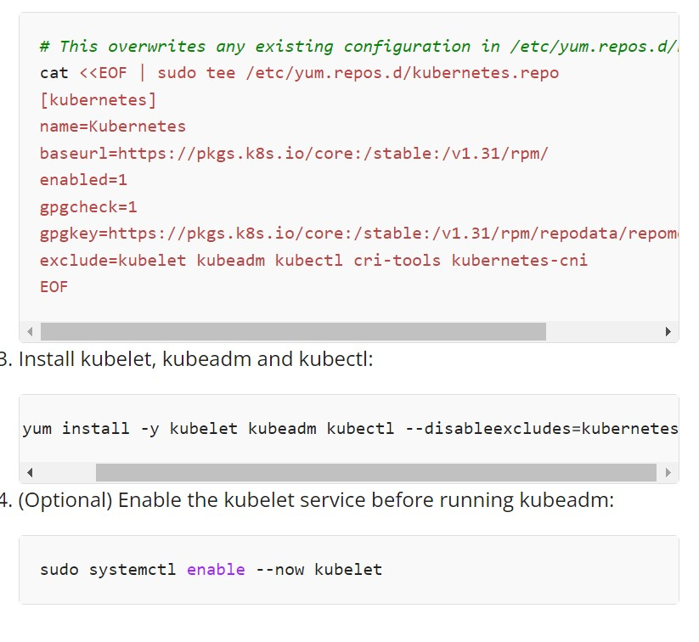

Copy the above given steps and paste in the terminal. This will create a Kubernetes repository, install kubelet, kubeadm and kubectl and also enable the services.

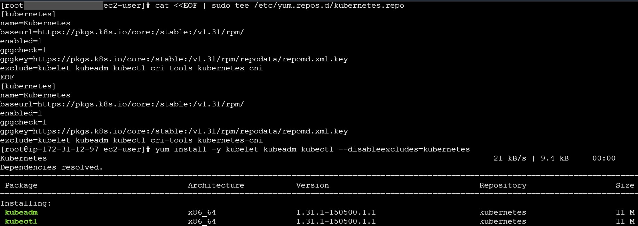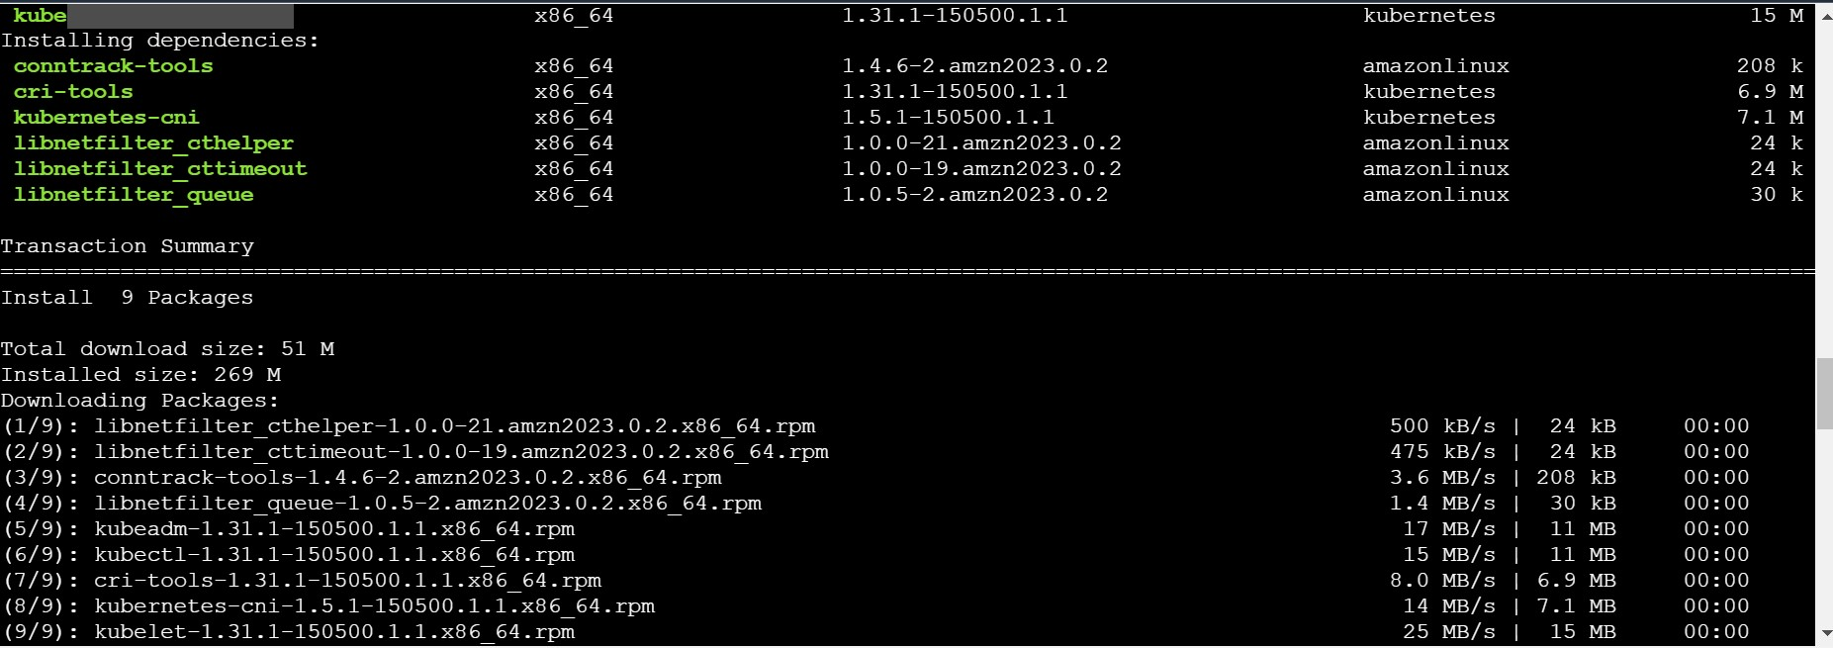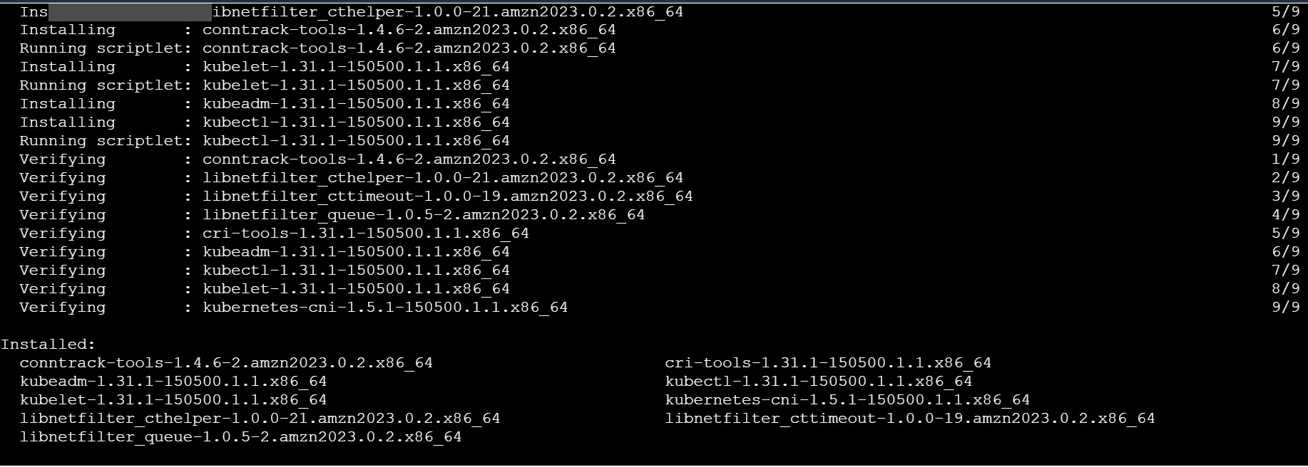

1. We can check if repository has been created by using yum repolist command.

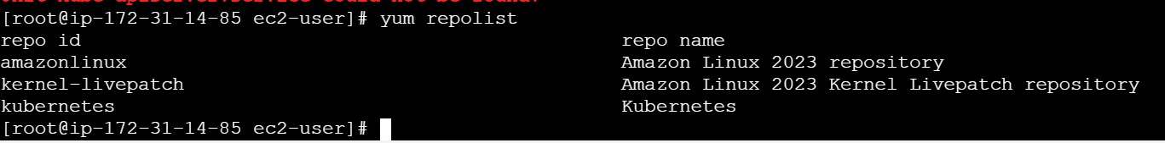

1. Now we will be initializing the kubeadm. For that “kubeadm init” command has to be used. It may show errors but those can be ignored by using

--ignore-preflighterrors=all

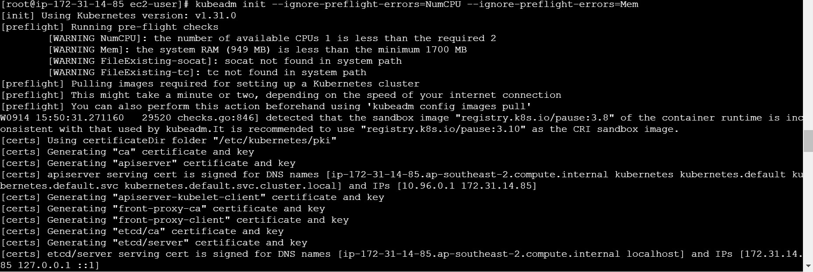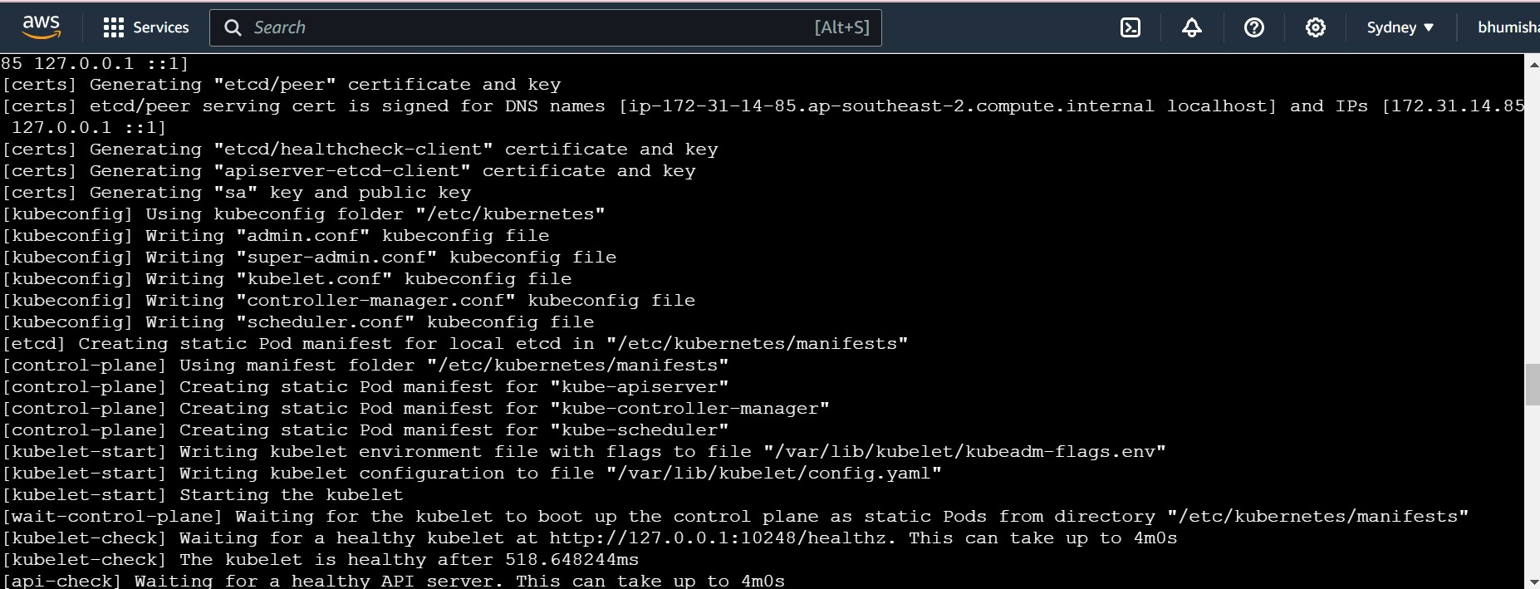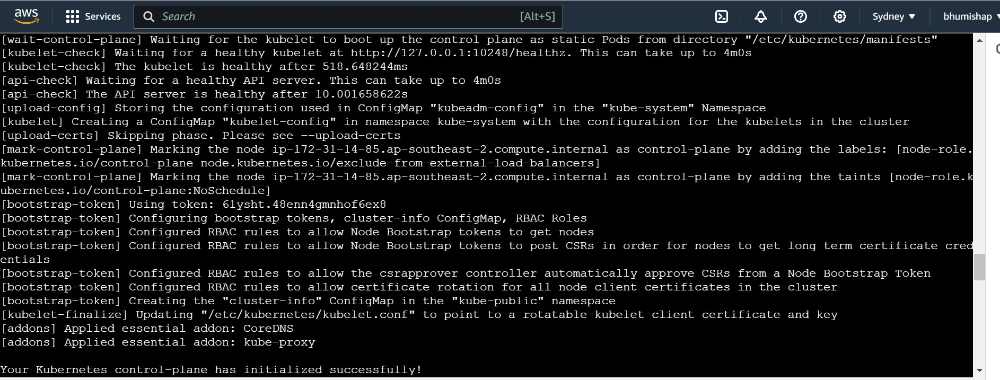

1. On successful initialization we need to copy and paste the following commands on the master machine itself:

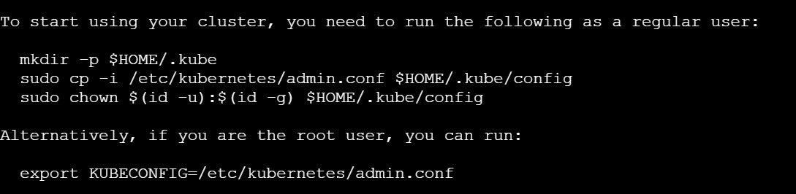

1. Next copy and paste the join link in the worker nodes so that the worker nodes can join the cluster.



1. After performing join commands on the worker nodes, we will get following output:

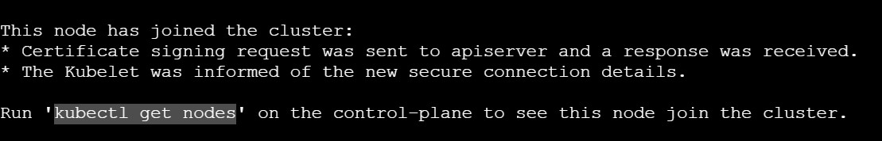

1. Once again when you run kubectl get nodes you will now see all 3 nodes have joined the cluster.

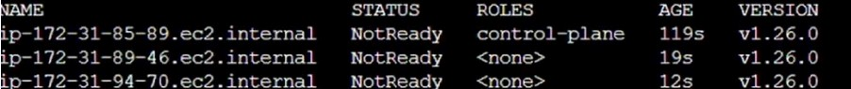

Conclusion:

This experiment successfully demonstrated the creation of a Kubernetes cluster and the successful addition of all three nodes using various commands. Errors encountered during initialization can be addressed in two ways: 1) by ignoring the errors, or 2) by upgrading the instance type to t3.medium or t3.large if the issues are due to insufficient memory or CPU resources.